**Using the variables and collections**

1. Sign into [Power Apps](https://make.powerapps.com/).
2. On the Home screen, select **Canvas app from blank**.

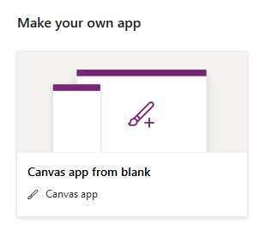

1. Name your app **New App**, format **Tablet** and click **Create**.

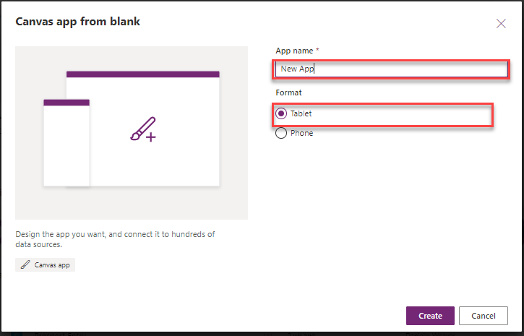

1. On the App Object

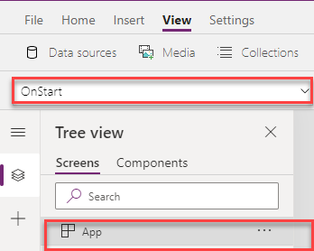

1. Set the **OnStart** property to this property to this formula:

PowerApps Formula

ClearCollect(collectCustomer,

{CustomerNumber: 7470, InvoiceNumber: "INV70817"},

{CustomerNumber: 4259, InvoiceNumber: "INV29595"},

{CustomerNumber: 8251, InvoiceNumber: "INV74302"},

{CustomerNumber: 2338, InvoiceNumber: "INV35115"},

{CustomerNumber: 1524, InvoiceNumber: "INV82337"},

{CustomerNumber: 1530, InvoiceNumber: "INV82338"}

);

Set(varUserDisplayName, User().FullName)

1. Click the **ellipsis (…)** and Select **Run OnStart** this will run the **OnStart** formula you just entered and populate the collection.

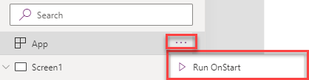

1. Select the **Insert** tab and add **Gallery**, set its **Items** property to **collectCustomer**.

Make the below changes to the **Gallery**:

Copy

Layout: Title and subtitle

Height: 650

Title label **Text** property to ThisItem.CustomerNumber

Delete the NextArrow icon

1. In the Gallery, Select the **Title** label and **Insert** tab to add an **Icon** select the **Trash can** icon. Move the Trash icon to the right side of the gallery.

Your Gallery will now include the Trash can icon.

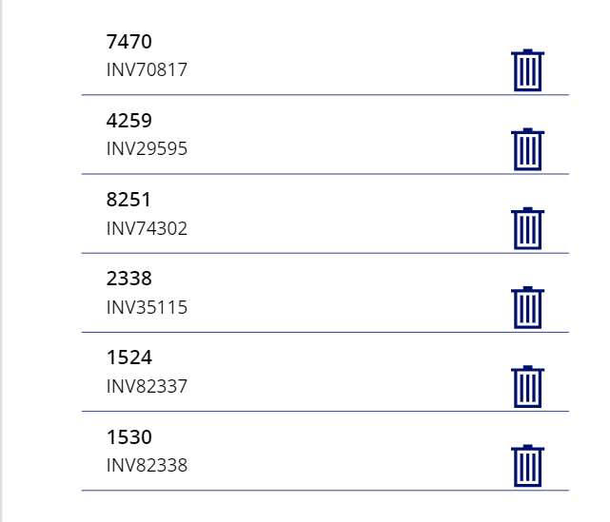

1. Select the **Trash icon** and the below formula to its **OnSelect** property:

PowerApps Formula

Remove(collectCustomer,ThisItem)

1. Press and hold **Alt Key**, and select the first **Trash can** icon.

This will delete the selected row from the collection. While this process works, you probably want to give a warning message that the row will be deleted.

Now let's create a popup warning to inform the user about the deletion and give them an option to cancel.

1. First change the **OnSelect** of the **Trash can** icon to the below:

PowerApps Formula

UpdateContext({varPopup:true})

1. To create the Popup, Click on the screen and Select the **Insert** tab to add an **Icon** select the **Rectangle** icon from the list.
2. Make the below changes to the **Rectangle** icon:

Copy

Name: rectangle_backgrd

Size: 744 (width) X 720 (height)

Fill: RGBA(166, 166, 166, .50)

1. Add another **Rectangle** icon and make the below changes:

Copy

Name: rectangle_foregrd

Size: 744 (width) X 348 (height)

Fill: RGBA(255, 255, 255, 1)

BorderThickness: 1

1. Select the **Insert** tab and add **Text**
2. Make the below changes to the **Text** label:

Copy

Name: lbl_popup

Font size: 15

Font weight: Bold

Text alignment: Center

1. Set the lbl_popup **Text** to the below formula:

PowerApps Formula

varUserDisplayName & "

Please click Delete to confirm deletion of Invoice#" & " " & Gallery1.Selected.InvoiceNumber

1. Select the **Insert** tab and add **Button** , Name: button_Delete, set its **Text** property to Delete
2. Set the Delete **Button** **OnSelect** property to the below:

PowerApps Formula

Remove(collectCustomer,LookUp(collectCustomer,CustomerNumber=Gallery1.Selected.CustomerNumber));

UpdateContext({varPopup:false})

1. Select the **Insert** tab and add **Button**, Name: button_Cancel, set its **Text** property to Cancel
2. Set the Cancel **Button** **OnSelect** property to the below:

PowerApps Formula

UpdateContext({varPopup:false})

1. While holding down the Ctl-key Select the following controls:

Copy

rectangle_backgrd

rectangle_foregrd

lbl_popup

button_Delete

button_Cancel

1. Right-Click Select **Group** set the **Visible** property of Group1 the below:

Copy

varPopup

You have created a popup box that will delete the selected Customer from the gallery.

Let's test the Delete function.

1. Press and hold **Alt Key**, and select the **Trash can** icon for invoice# INV70817.

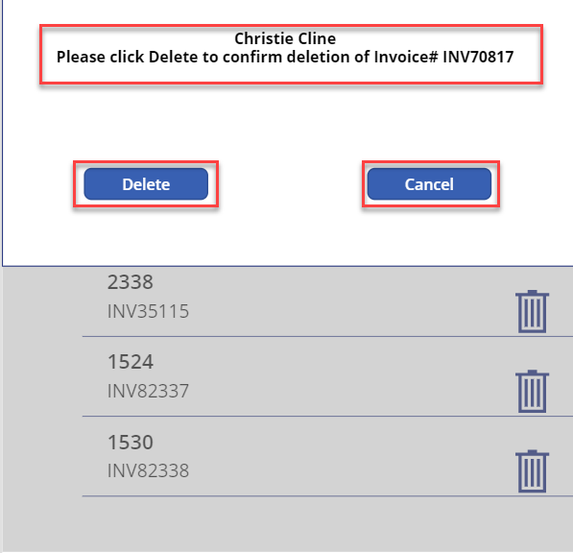

1. Click the **Delete** button, INV70817 is removed from the gallery.
2. Now Press and hold **Alt Key**, and select the **Trash can** icon for invoice# INV29595
3. This time Click **Cancel**, the popup window closes and INV29595 remains in the gallery.